11/3/2023

Jorge Trujillo

Project Management

Assessment ONE

|  |  |  |  |
| --- | --- | --- | --- |
| Name of Student | Jorge Eduardo Trujillo Paez | ID | 18574 |

**Assessment 1 – Case Study**

Contents

Instruction: 1

Duration: 1

Case Study: 2

Going Green application, Green IT Project Management 2

Project profile 2

Business situation 3

Your tasks: 4

Task 1: Identify Business Strategy and Gap 4

Analyse Strategy 4

Task 2: Recommend a feasible solution 4

Task 3: Produce a Project Charter 5

Task 4: Project Document 6

Task 5: Project Closure 9

Helpful web links to complete the assessment: 12

Search Index 13

## Instruction:

This task is to be completed individually. You need to analyse a case scenario and complete all the tasks mentioned after the scenario.

You need to demonstrate your IT project management ability to identify business strategy and gaps. You will also need to suggest a feasible solution to overcome identified gaps and produce a project charter along with a WBS to implement the proposed solution.

### Duration:

Trainer will set the duration of the assessment.

All my working can be checked at <https://wellsjohn220.github.io/pmt32023by12345>

## Case Study:

### Going Green application, Green IT Project Management

# Project profile

Going “Green” is a mission of many companies around the globe not just for reasons of environmental responsibility, but also for cutting costs in these extremely tight economic times. Green IT efforts represent a specific focus area within enterprises that hold attention to this trend. Green IT leverages information technology to streamline operations, cut costly waste, and reduce the impact on the environment. IT typically consumes only about 10% of an organization’s energy costs, but the net effect of a Green IT project is to go beyond just energy saving. To tackle the other 90%, a Green IT project extends into a variety of other departments, and to execute such an endeavour requires an effective project management function in order to identify and prioritize goals. A Green IT transformation can be a complex process.

Vital Statistics:

* Number of project tasks - 12
* Project duration - 16 months
* Project budget - $1,200,000
* Number of users – 50

Because I could not obtain Microsoft Project software. I used Google Sheets to make a Gantt chart template:

I also think using a simple case, which I knew well, could be better for my learning. Go to website:

Link URL: [https://docs.google.com/spreadsheets/](https://docs.google.com/spreadsheets/d/1nUk93YC-P-136wZSz6bXdNAjqIK4NBPwA_0ZAHn1Sww/edit?usp=sharing)

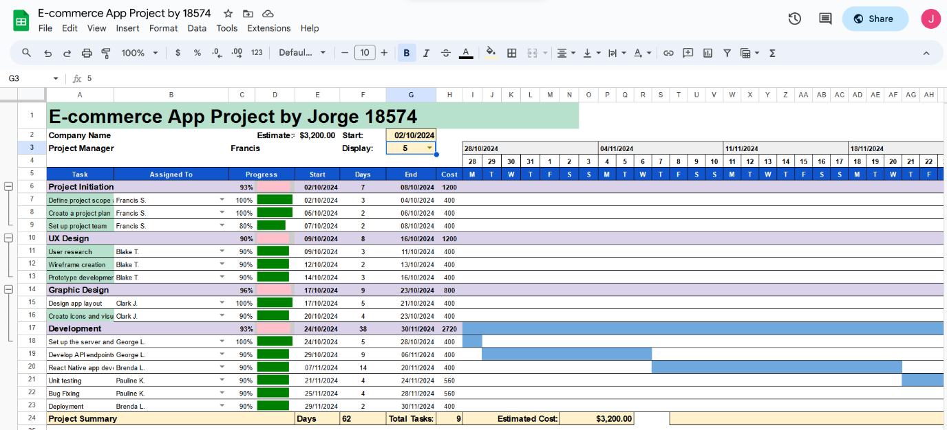

Tutor reference: <https://www.youtube.com/watch?v=8eKk0M2zGIk>

Or using GanttProject:

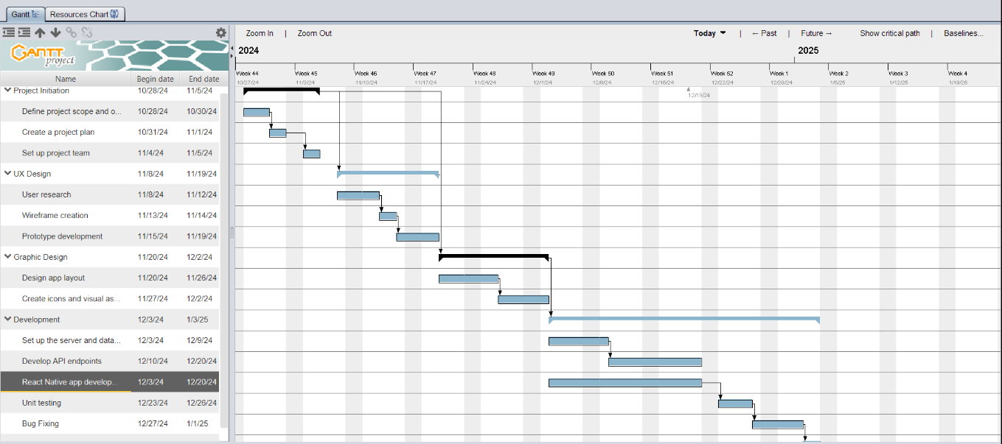

[https://tepjet4.github.io/Gantt Web/18574-resources.html](https://tepjet4.github.io/Gantt%20Web/18574-resources.html)

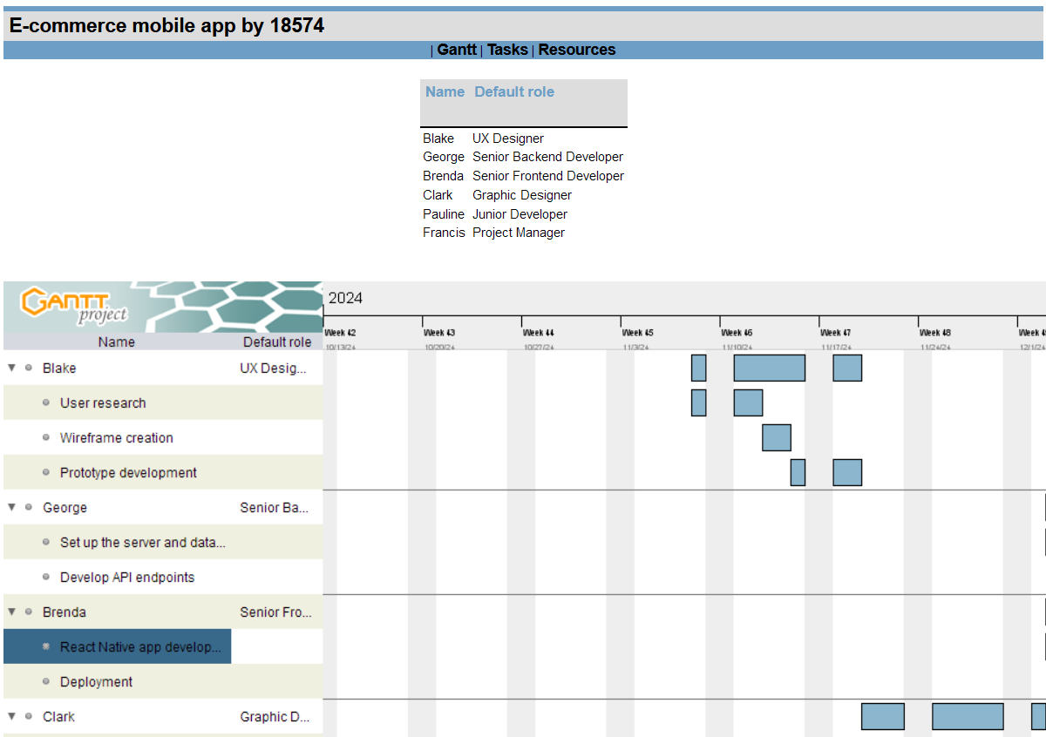

### Business situation

Sample Summary Report:

In order help college promotion, the college need good video film. I set the project and start it now…

…

## Your tasks:

### Task 1: Identify Business Strategy and Gap

Document the business’s strategies of “Green IT” and also summarise the components required changes for the participating organisation to implement “Green IT Project”. (Min. 300 words)

Business strategy is a planning function of any organisation. Business strategy incorporates having a strategic plan.

### Analyse Strategy

The strategic plan of an organisation sets out the goals a business hopes to achieve within a specified period of time. It also helps the organisation understand the environment within which they operate and the market forces that affect them.

An analysis of the current strategic plan enables you to understand the goals of your organisation. However, in order to analyse the strategic plan, you first need to understand the structure and purpose of a strategic plan. This topic describes the elements that make up a strategic plan.

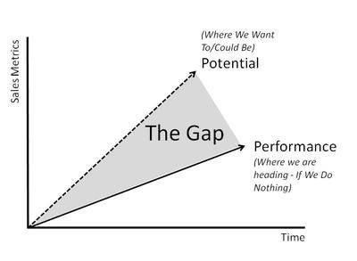The green project we need defined every requirement. The gap which is between your plan and reality always need your notice. So you need do your best to investigate your Green Project.

### Task 2: Recommend a feasible solution

Assume “Wells International College” is thinking of going “Green” and asked for your assistance in this project. Research different project management applications on the Internet to compare with the Green IT project management application and recommend a feasible solution with proper reasons for Windsor. (Min. 300 words)

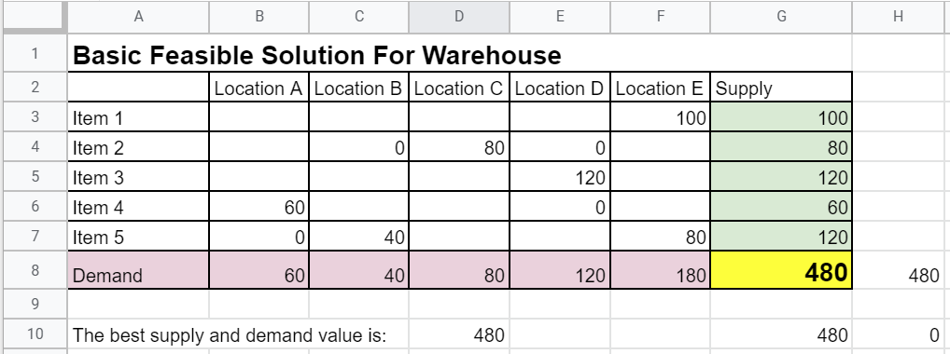

See above simple example. Any warehouse, Supply must equal to demand or very close. It is the best business solution.

### Task 3: Produce a Project Charter

Please view my project charter (here only show part):

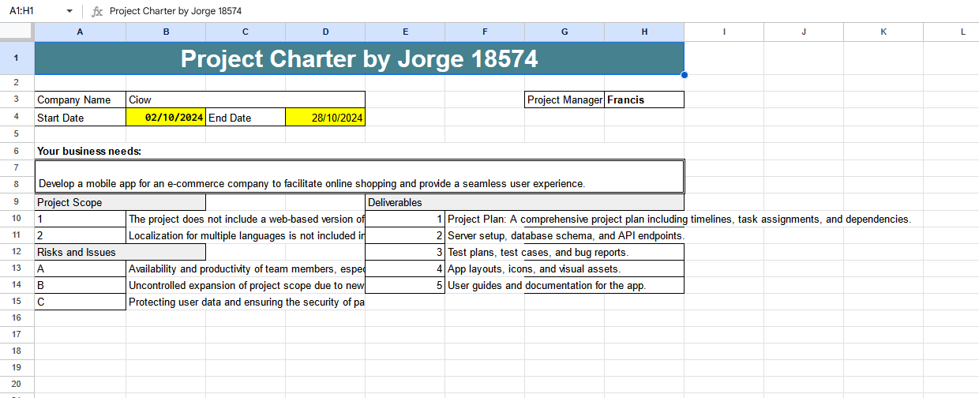

Develop a project charter for the Windsor project specifying project start date, finish date, approximate budget, project manager, project team with roles and responsibilities, project objective, project approach and stakeholders.

Name: ?

Description: Help business

Manager: John

Date Approved:

...

### Task 4: Project Document

My website can be checked at: <https://wellsjohn220.github.io/pmt32023by12345>

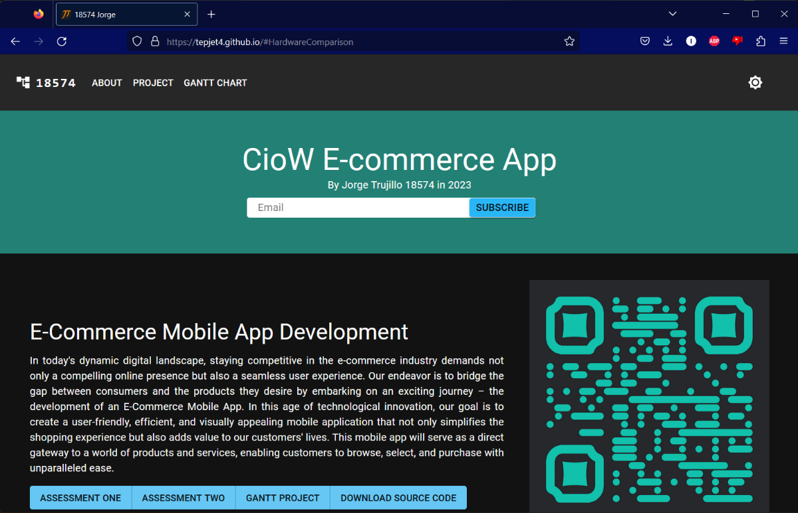

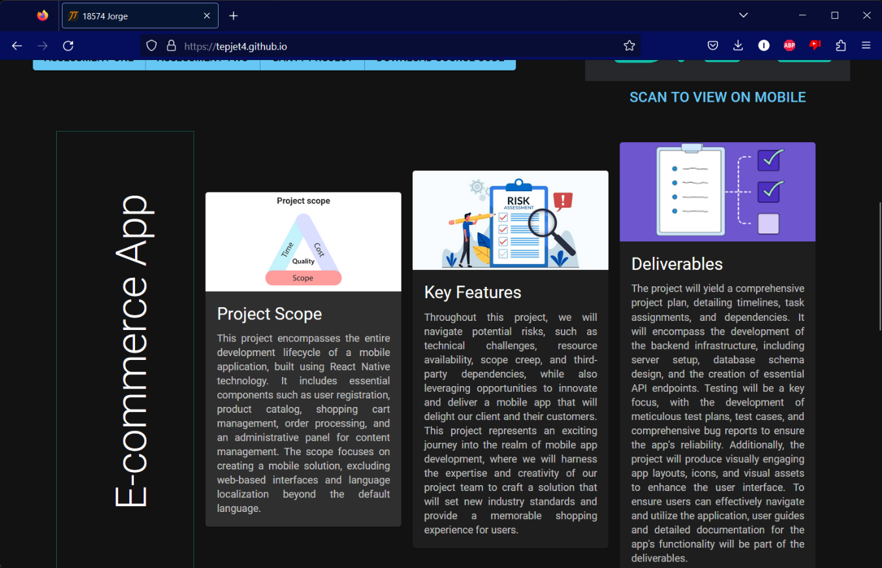

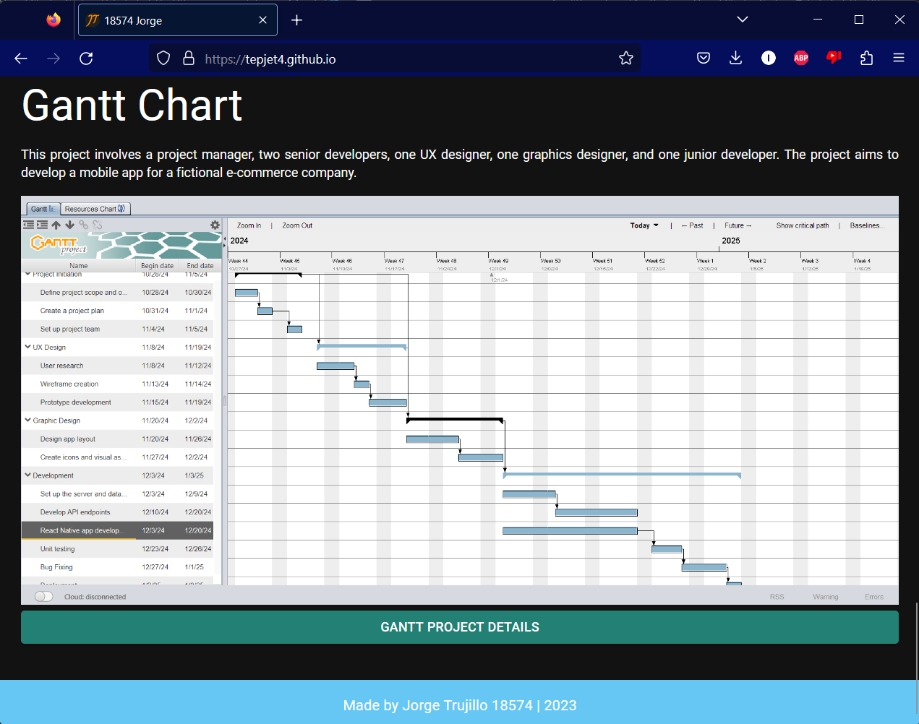

Refer to your current project, you have been asked to develop a project plan for WIC. Project plan outline as following:

In my Green project, I design following topics:

* Introduction (Select one recommendation from Task 2 for implement project plan)

(Please see above my project charter, it is clear indication)

* Project background

(Make promotion video for the college)

* Related factor to organization
* Scope and objective of the project
* Information gathering plan and approach
* Gathering method, can be one of the following
* Interview
* Questionnaire
* Observation
* Detail of information repositories
* Feasibility studies
* Technical (need higher tech made this software more stable and powerful)
* Operational
* Economical
* Social
* Project plan and schedule (Development and Maintenance)
* Work breakdown structure
* Gantt Chart
* Milestone

Above last black diamond is the milestone!

* Project Deliverable
* Communication plan

Communication plan should include communication and consultation with all the relevant stakeholders. (From college learn guide)

* Deployment Plan (If needs)
* Training Plan (If needs)
* Recourse and budget, (budget has been limited by WIC Capital Expenditure of current fiscal year for Hardware $80,000, Software $10,000, and Outsourcing man-hours $100,000)

Above image is showing my current green project displaying part of budget!

* Risk Management
* Risk identified
* Contingency plan
* Change management
* Change control
* Conflict management

### Task 5: Project Closure

Prepare project closure document template as following:

* Project Sign-off document

When project sign off, it means your project finished. So you need make one clear sheet to tell everyone about your project. It will include:

* project start date
* project manager
* project finish date
* if something is going wrong
* ...

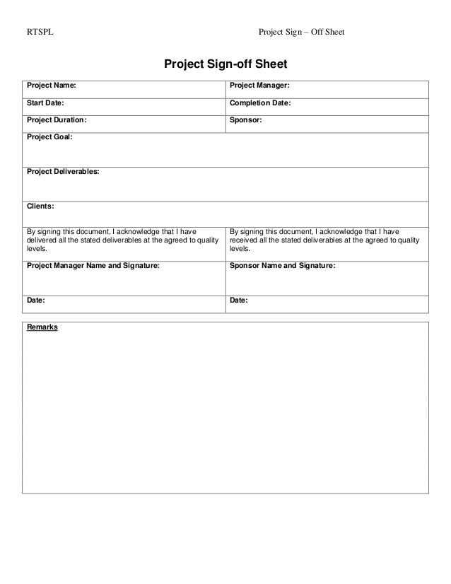

* Project evaluation document

You need show about your project, good or not enough. Summary all about your project

It may include:

* Budget evaluation
* Quality evaluation
* Benefit evaluation
* Etc...

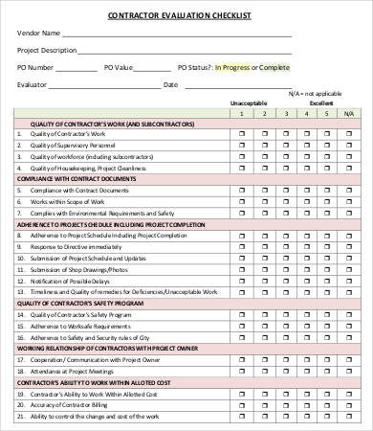

* Lesson learned template
* What we have learn through this project
* What we need to do if next project start
* What we learn some lesson. We could not make same mistake again.
* Etc.

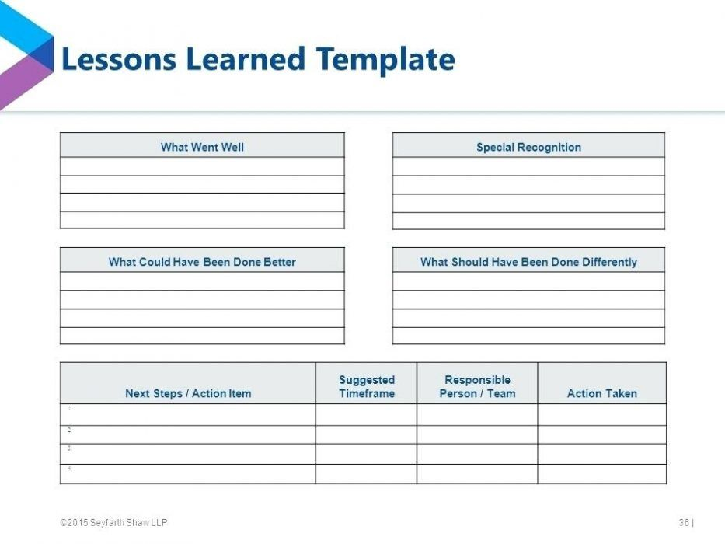

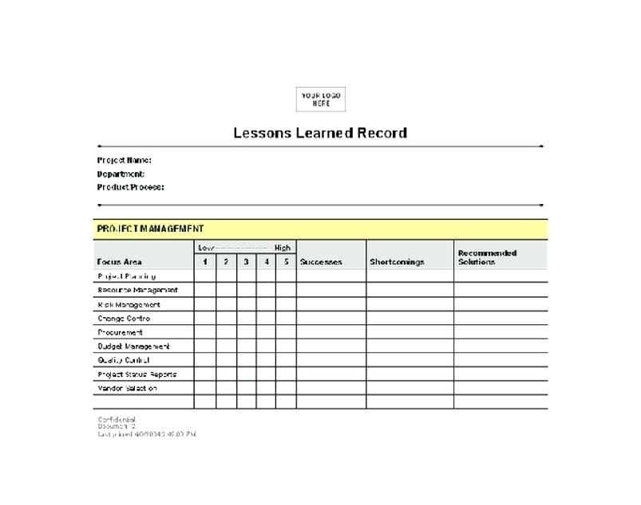

## Helpful web links to complete the assessment:

## Search Index

B

Benefit evaluation 10

Budget evaluation 10

F

feasible solution 1, 4

P

project sign off 9

Q

Quality evaluation 10

S

same mistake 10

scenario 1

specific focus 2